Automated Submission Tool

The automated submission tool enables software development students to check for the correctness of their code. The tools tests submissions correctness by compiling and running the code providing execution report. You can test a single project or multiple projects with a single run. The tool is provided as an executable jar file which you can run directly from your project or workspace providing input text file to represent user input and an expected output file which is used as reference to successful execution.

# Students Project structure

Your exercise projects must meet the following structure in order to be compliant with the automated test tool.

Your project must contain a source folder dedicated to the code of your exercise.

Every program is must be implemented in a library, no classes should be placed in the source folder.

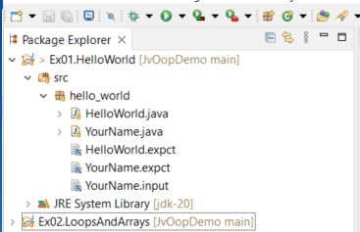

# Obtaining the demo workspace:

Go to the following GitHub page: <https://github.com/Danielli-Itai/JvOopDemo>

Then click on “Code” then select “Download ZIP”, once you downloaded the archive file, extract the file on your computer. The project consists of demo projects and the “RunTime” project which contains the JvOopTest.jar executable jar you will use.

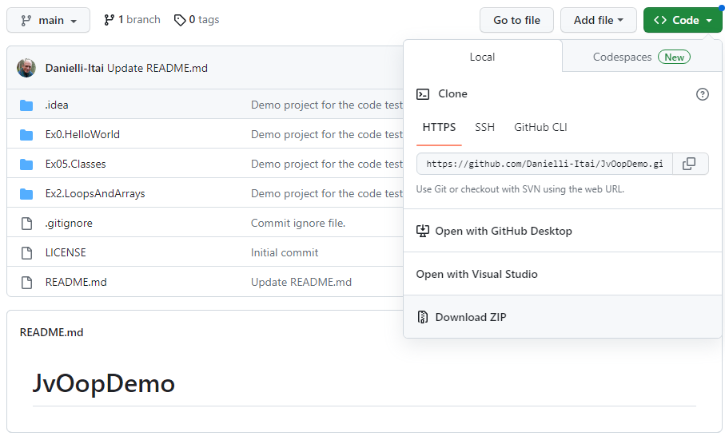

# Running the example:

The example project is tested for InteliJ IDE, right click the JvOopTest.jar; this is an executable jar that will test the code. Then select “Modify run configuration” and in the dialog add the program argument “run_workspace” then set working directory to the project parent folder.

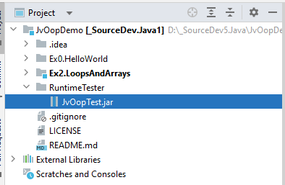 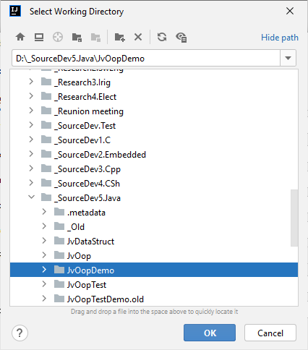 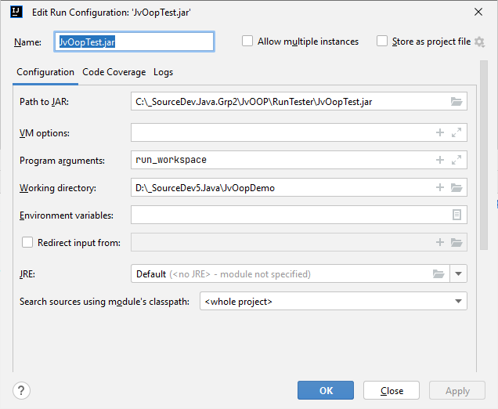

Once you completed setting the run configuration it will appear as part of your run configurations, and you need to simply run it. Once running the test process appears on your “Console” view till the message “Test Completed” appears.

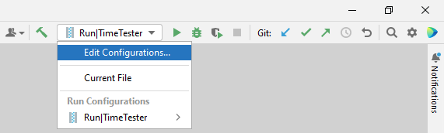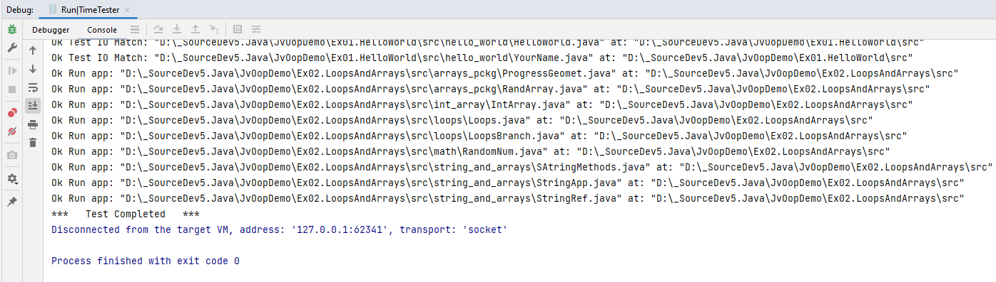

# Usage:

For the tool to work well each project should have the code within a source folder (appearing as “src” in the demo. The files should be organized in packages where each package contains the classes and executable class for this package.

Each executable class test depends on the files which carry the name of the class and the extension defines the file type, these are the file types you can use.

Expected output: Text file containing the expected output <Class name>.expct

File example the YourName.java expected file is YourName.expct

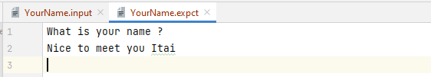

User input: Text file containing the user input provided to the application <Class name>.input

For example the YourName.java input file is YourName.input

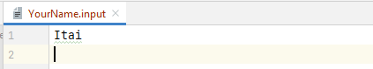

# The report:

Once the test is completed a report file is created at the workspace folder containing the test results. These are the results reported by the tester.

“Ok Test IO Match” - the output matches the expected output.

“Error Test IO Fail” - the output does not match the expected output.

“Ok Run app” – the application ran correctly output was not checked.

“Error Run Fail” – failed to run the application

# Terms of use:

[**Use**](https://www.lawinsider.com/clause/limitation-to-software-warranty) of Software Any software that is available on the Services ("Software") is the copyrighted work of Itai Danielli and/or its licensors. Copying or reproducing the Software to any other server or location for further reproduction or redistribution is strictly prohibited, unless such reproduction or redistribution is permitted by a license agreement accompanying such Software. You may not create derivative works of the Software, or attempt to decompile or reverse-engineer the Software unless otherwise permitted by law. Use of the Software is subject to the license terms of any license agreement that may accompany or is provided with the Software. You may not download any Software until you have read and accepted the terms of the accompanying software license. THE SOFTWARE IS LICENSED “AS IS.” YOU BEAR THE RISK OF USING IT. ITAI DANIELLI GIVES NO EXPRESS WARRANTIES, GUARANTEES, OR CONDITIONS. TO THE EXTENT PERMITTED UNDER APPLICABLE LAWS, ITAI DANIELLI EXCLUDES ALL IMPLIED WARRANTIES, INCLUDING MERCHANTABILITY, FITNESS FOR A PARTICULAR PURPOSE, AND NON-INFRINGEMENT.